EX.NO: 2
DDL Commands with Constraints (PRIMARY KEY, UNIQUE, CHECK)
AIM
To create a table using DDL commands with PRIMARY KEY, UNIQUE, and CHECK constraints.

PROCEDURE
- Select the MobileDB database.
- Create a new table named MobileSales_Constraint with the required constraints.
- Display the table structure using the DESC command.
- Insert records into the table.
- Display all the records to verify the constraints.
- Observe the output and verify that the constraints are successfully applied.

COMMANDS
1. Select the Database
USE MobileDB;

2. Create the Table with Constraints
CREATE TABLE MobileSales_Constraint
(
MobileName VARCHAR(20) PRIMARY KEY,
Price INT UNIQUE,
CustomerReview DECIMAL(2,1) CHECK (CustomerReview BETWEEN 1 AND 5),
UnitsSaled INT,
ModelYear INT CHECK (ModelYear BETWEEN 2023 AND 2026),
Storage INT CHECK (Storage IN (128,256))
);
3. Display the Table Structure
DESC MobileSales_Constraint;

4. Insert the Records
INSERT INTO MobileSales_Constraint
VALUES
('OnePlus14R',25000,4.0,10000,2025,128),
('Redmi12',20000,4.0,10000,2024,128),
('SamsungS10',30001,4.1,5000,2023,256),
('iPhone12',45000,3.9,4000,2024,128),
('MotoG36',21000,4.0,2000,2025,128),
('Pixel6A',30000,4.5,5000,2024,256),
('iPhone14',49000,4.0,5500,2025,128),
('IQZ6',25001,4.2,7000,2025,256),
('OnePlusCE5',29000,4.4,2000,2026,256),
('iPhone15',70000,4.0,2000,2026,128);

5. Display All Records
SELECT * FROM MobileSales_Constraint;

6. Display the Table Structure Again
DESC MobileSales_Constraint;

OUTPUTS
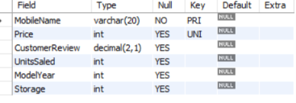
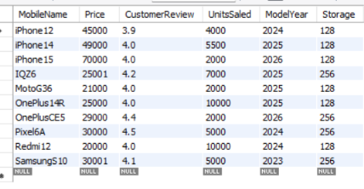

RESULT
Thus, the table MobileSales_Constraint was successfully created with PRIMARY KEY, UNIQUE, and CHECK constraints, and the constraints were verified successfully.

